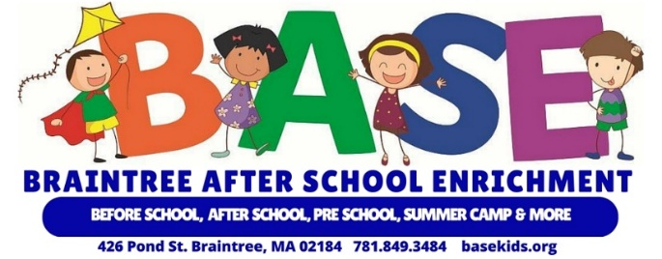
September 2022
Dear Parents,
We are pleased to announce that we’re partnering with Blackbaud Tuition Management to process and collect tuition and fees for the 2022/2023 school year.
Tuition Management enables you to:
Select a payment method that works best for you:
- Choose to receive a monthly invoice.
- Set up recurring automatic payments from your bank account or credit card.
- Visa, MasterCard, Discover, and American Express are accepted. (2.85% fee is charged to all credit card and debit card transactions)
- Pay Near Me™ Cash Payments at Retail Stores Payers can make cash payments at 7-Eleven™, Family Dollar™, and CVS™ pharmacies by presenting their payment coupon to a clerk to process. There is a $4.99 fee charged for each cash payment made at a retail store *** NEW this year for BASE
Access your account online to:
- Review account history, transaction details, and print monthly invoices.
- Edit your contact information, password, and payment method.
- Make a payment or set up recurring payments.
Receive payment and follow up reminders:
- For recurring payments, a reminder is emailed 7-10 days before the due date.
- For missed payments or outstanding balances, you’ll receive an email and text message.
Speak with a customer service representative.
- Families can access their accounts to check balances and make payments 24/7.
- Spanish speaking representatives are available.
- Call toll free to make payments at (888) 868-8828.

Please go online before August 19th to enroll in Tuition Management at: https://enroll.blackbaud.school
Our school code is: __11664___.

Thank you for selecting Braintree After School Enrichment for your child’s education.
Sincerely,
Braintree After School Enrichment

